Bar Charts-Questions
Key Stage 3: 2003 Paper 2 Level 3-5
1.
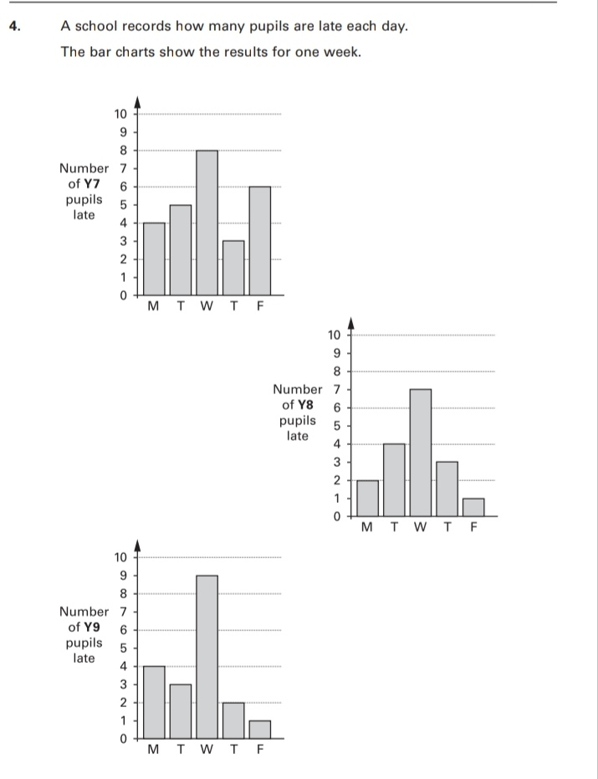
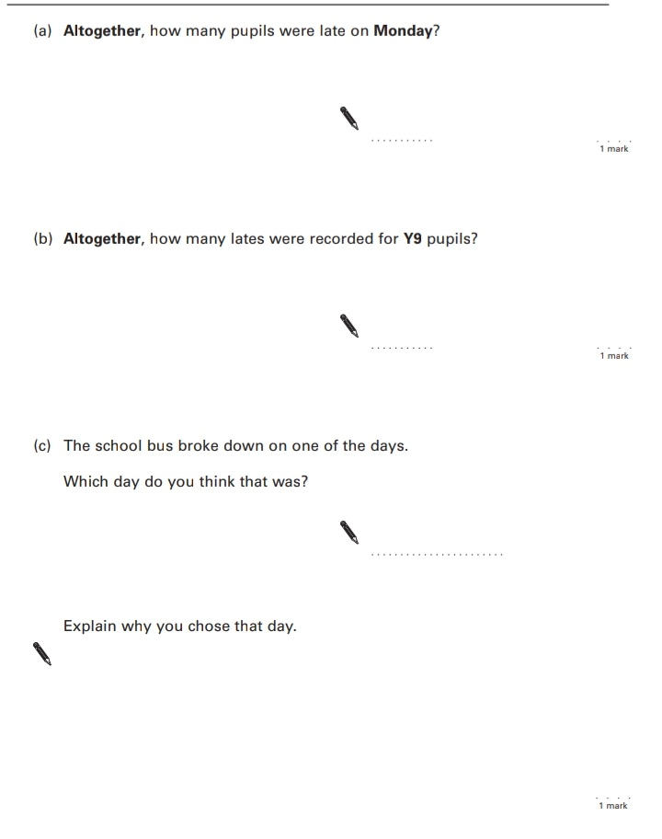
Key Stage 3: 2004 Paper 1 Level 3-5
2.
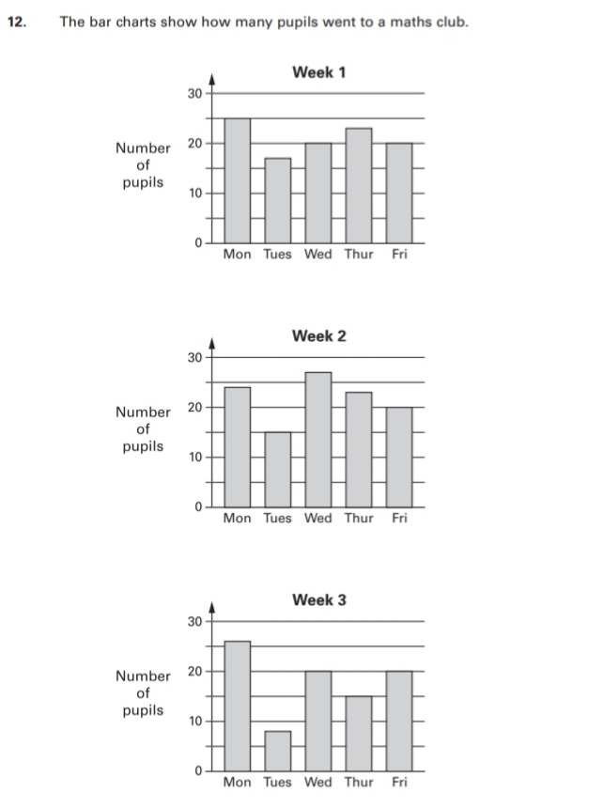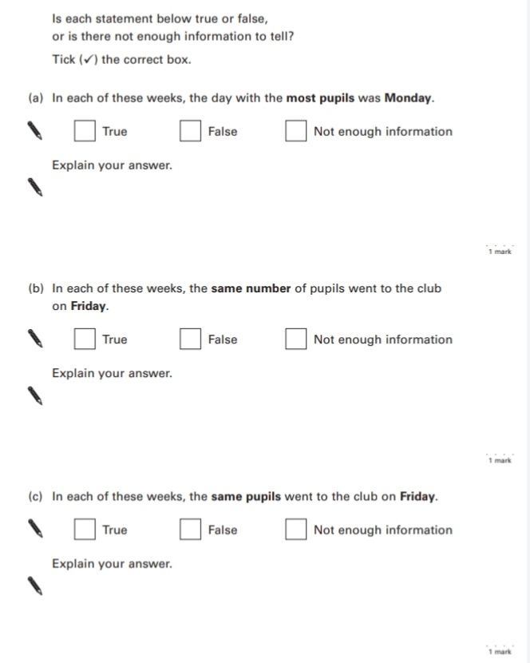
Key Stage 3: 2004 Paper 2 Level 3-5
3.
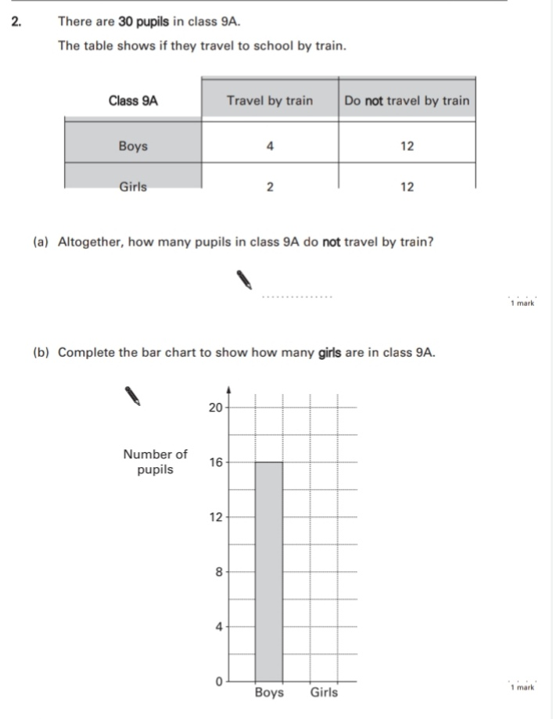
Key Stage 3: 2004 Paper 1 Level 4-6
4.
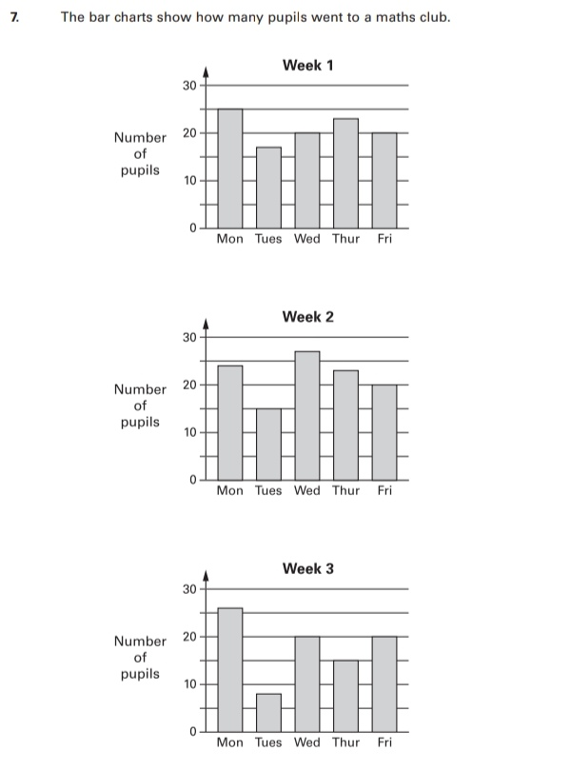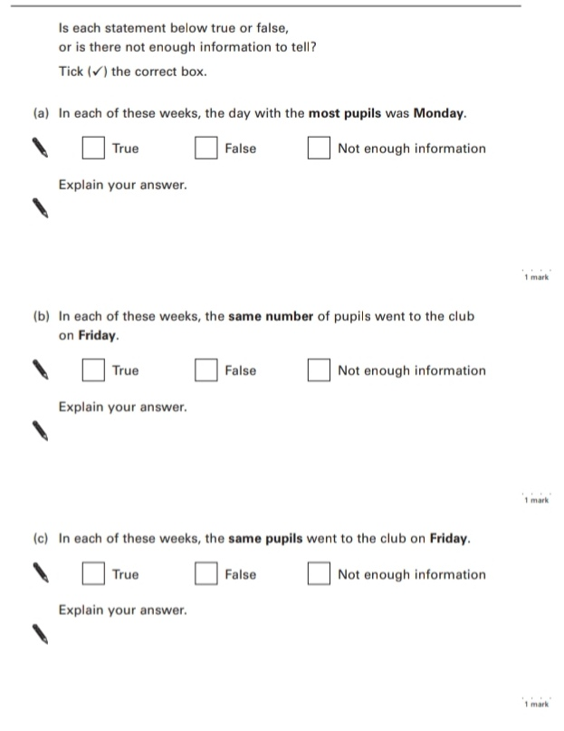
Key Stage 3: 2005 Paper 1 Level 3-5
5.
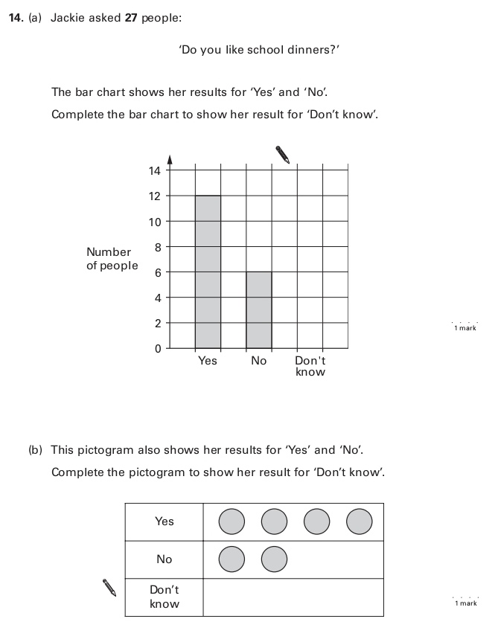
Key Stage 3: 2005 Paper 2 Level 3-5
6.
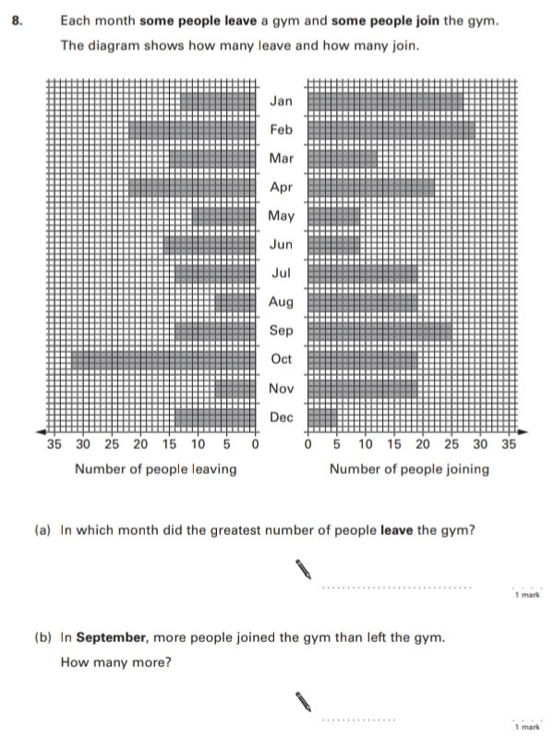
Key Stage 3: 2005 Paper 1 Level 4-6
7.
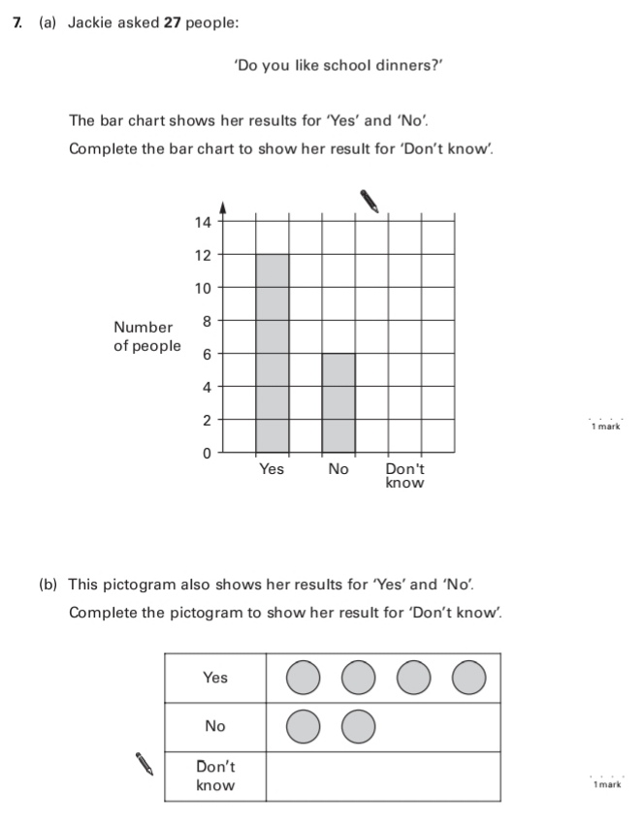
Key Stage 3: 2005 Paper 2 Level 4-6
8.
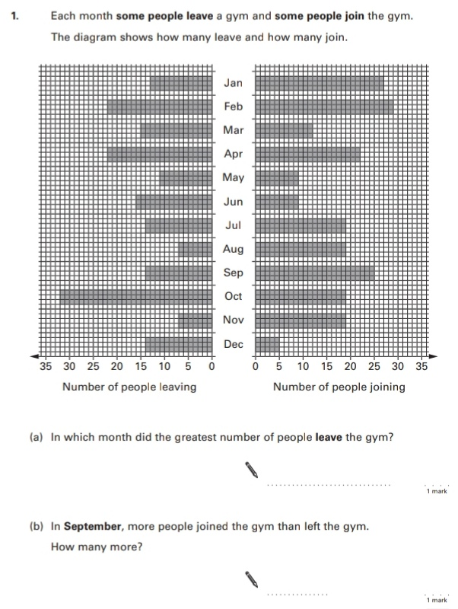
Key Stage 3: 2006 Paper 1 Level 3-5
9.
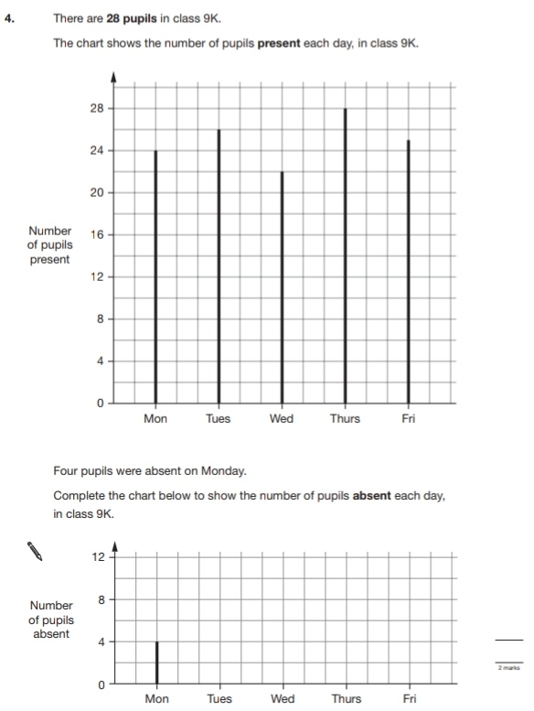
Key Stage 3: 2007 Paper 2 Level 3-5
10.
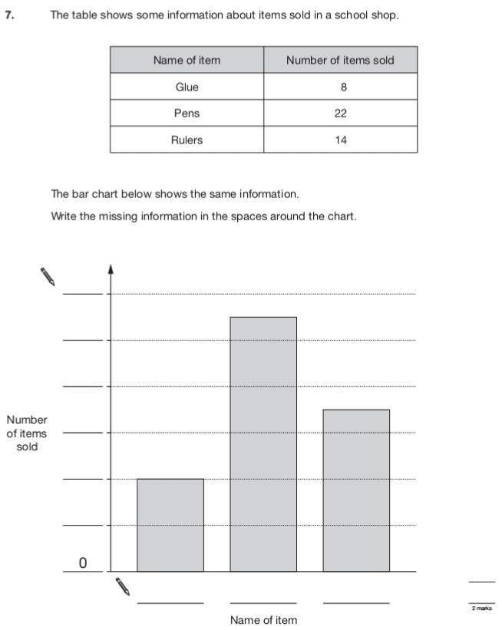
Key Stage 3: 2008 Paper 1 Level 3-5
11.
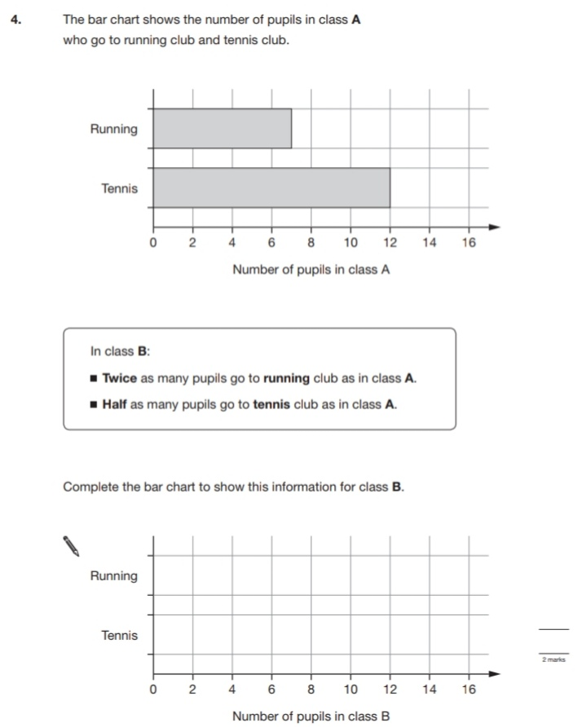
Key Stage 3: 2010 Paper 2 Level 3-5
12.
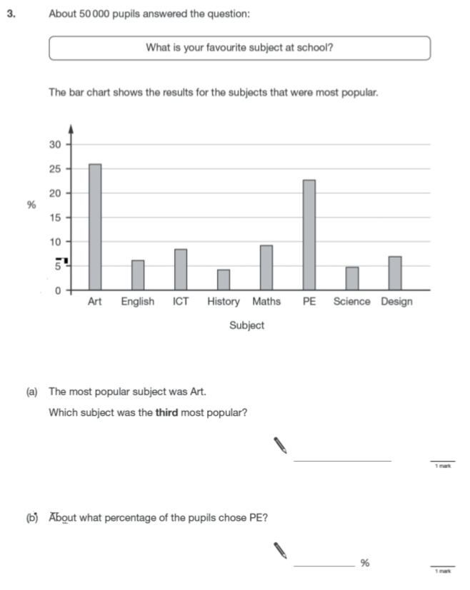
13.
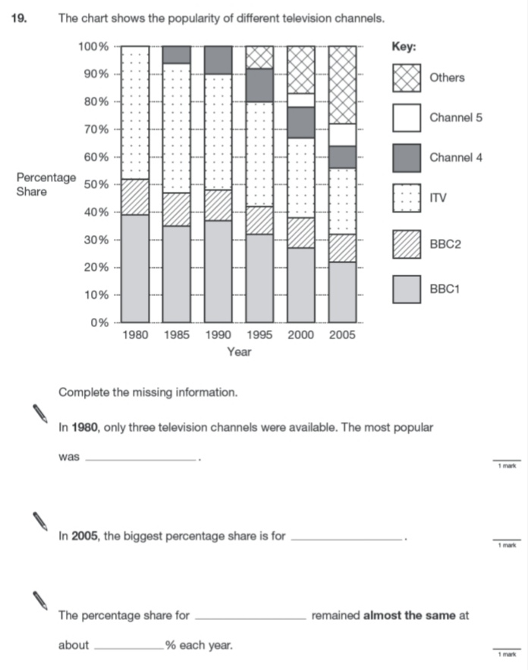
Key Stage 3: 2010 Paper 2 Level 4-6
14.
